**REPORT**

Zajęcia: Analog and digital electronic circuits

Teacher: prof. dr hab. Vasyl Martsenyuk

**Lab 1**

06.03.2025

**Topic:** "Spectral Analysis of Deterministic Signals"

**Variant: 13**

Rafał Żmuda

Informatyka II stopień,

stacjonarne,

1 semestr,

Gr.2b

1. **Problem statement:**

Each student is assigned a unique variant of the task.

For each variant, students must:

• Synthetically generate the specified grayscale image and audio signal.

• Perform multidimensional signal analysis including Fourier transform, filtering, and visualization.

• Compare time and frequency domain representations.

**2. Input data:**

**Image**: Image with only one vertical line in the center.

**Audio**: High-frequency sine burst (3000 Hz) with silence.

**3. Commands used (or GUI):**

1. Input data generation

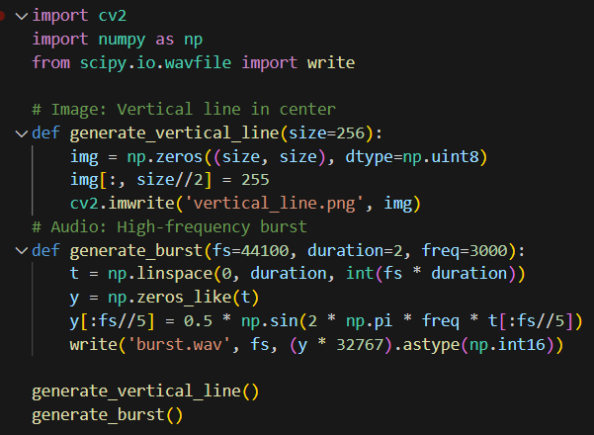

1. Image Analysis:

The code performs a 2D Fourier Transform on the generated image to compute its frequency spectrum.

Applies a low-pass filter to the frequency spectrum to remove high-frequency components.

Visualizes the original image, its magnitude spectrum, and the filtered image.

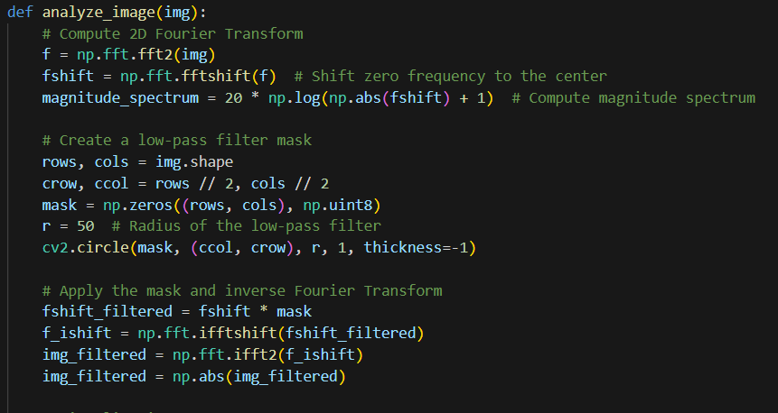

Visualization output:

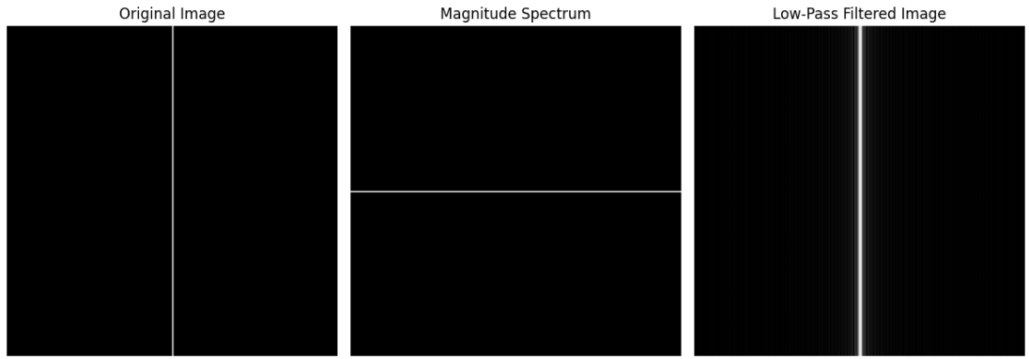

1. Audio Analysis:

* Computes the Fourier Transform of the generated audio signal to analyze its frequency components.
* Visualizes the audio signal in both the time domain and the frequency domain.

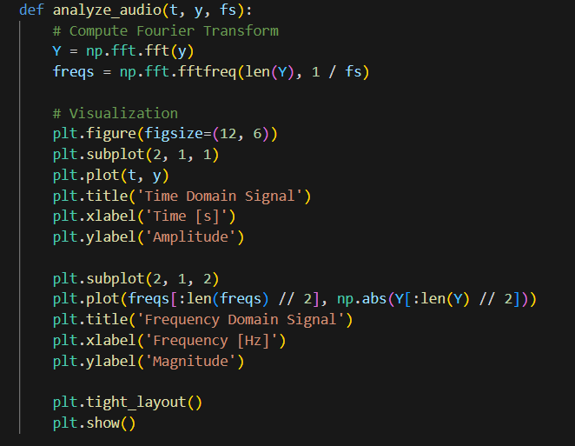

Visualization output:

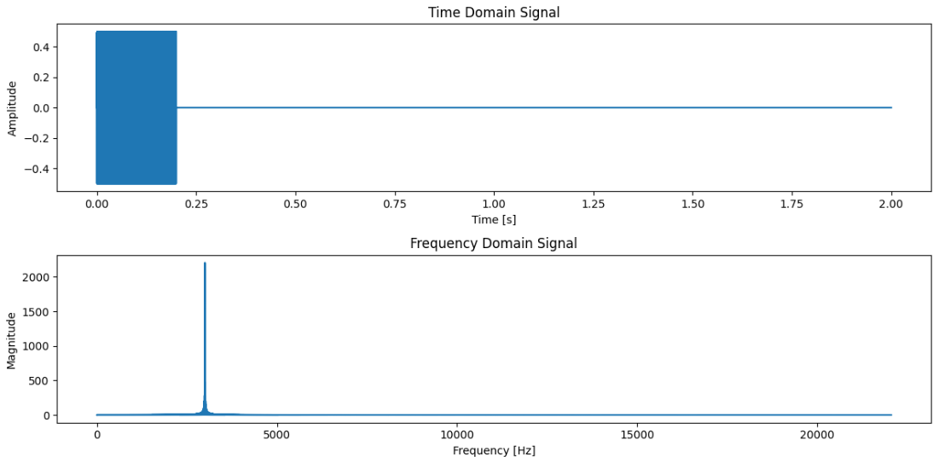

Link to remote repository: https://github.com/RafalZmu/School

**5. Conclusions:**

This task demonstrates the application of digital signal processing techniques using Python and its powerful libraries. By utilizing tools like Fourier transforms, low-pass filtering, and signal visualization, it showcases how DSP can analyze and manipulate signals in both the time and frequency domains. Technologies such as numpy for numerical computation, cv2 for image processing, and matplotlib for data visualization enable efficient and intuitive workflows. These methods are foundational in fields like telecommunications, audio engineering, medical imaging, and machine learning, offering vast possibilities for signal analysis, enhancement, and transformation in real-world applications.